

L.M. Geoinformatics Engineering

AA 2021/21

HYPERMEDIA APPLICATIONS

Design Document

**Date**: 25/07/2021

# **Authors**: Matteo Bresciani – mtr. 944639 - matteo.bresciani@mail.polimi.it

Gabriele D’Ascoli – mtr. 944275 - gabrieleangelo.dascoli@mail.polimi.it

**Link: https://toptech-polimi.herokuapp.com/**

**Contents**

1. Abstract……………………………………………………………………………………………………………………………………….…..3

2. Graphical Representation……………………………………………………………………………………………………….…….….4

2.1 C-IDM Diagram .4

2.1.1 C-IDM Notes………………………..……………………………………………………………………………………………………..5

2.2 P-IDM Diagram………………………………………………………………………………………………………………………………...6

2.2.1 P-IDM Notes……………………………………………………………………………………………………………………………....7

3. Content tables……………………………………………………………………………………….………………………………………...8

4. Mapping Content tables into pages……………………………………………………………………………..….……………..10

5. Visual Design (Wireframe and screenshots)………………………………………………………….………………………..11

5.1 Commented low fidelity wireframes……………………………………………………………………………………………….11

5.2 Commented high fidelity wireframes……………………………………………………………………………………………..21

6. Scenarios……………………………………………………………….……………………………………………………………………….31

6.1 Case 1………………………………………………………………………………………………..…………………………………………..31

6.1.1 Textual narrative………………………………………………………………………………………………………….…………..31

6.1.2 Sequence……………………………………………………………………..…………………………………………………………..31

6.2 Case 2…………………………………………………………………………………………………………..………………………………..33

6.2.1 Textual narrative…………………………………………………………………………………………………..………………….33

6.2.2 Sequence…………………………………………………………………………………..……………………………………………..33

6.3 Case 3………………………………………………………………………………………..…………………………………………………..35

6.3.1 Textual Narrative………………………………………………………………………………………………………………………35

6.3.2 Sequence……………………………………………………………………………..…………………………………………………..36

**7. DB Design……………………………………………………………………………………………………………………….………………39**

7.1 Relational Tables…………………………………………………………………………………………………………………………….39

7.2 ER……………………………………………………………………………………………………………………………………………………40

1. **Abstract**

This document contains the decisions made regarding the design specification of the project of the Hypermedia Application (Web and Multimedia) course for the academic year 2020/2021.

The project consists in designing and implementing a website for an ICT company.

The document is composed by the IDM models (interactive dialogue model) that define which are the main concept of the website (C-IDM) also providing a logical description of the pages structure (P-IDM), the scenarios to better understand the main idea behind the navigation and the contents provided by the website the content tables with their mapping with the pages, then the low and high fidelity wireframes of our website and how it will look like after the development and at the end the Entity Relationship diagram that describe the structure of the database.

**Every decision has been made in order to optimize the content of the website, making it simple and attractive.**

**Diagrams and Wireframes are created using *draw.io and Figma.***

1. **Graphical Representation**

2.1 C-IDM

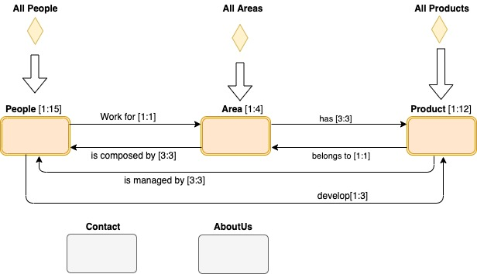

Figura 1 C-IDM describes the content of the web site in the large

2.1.1 C-IDM Notes

Here is a brief description of diagram’s component.

Topics:

* Contacts: relevant contacts for the website, include a form to fill with information to get in contact with the company.
* About us: general information about the company

Kind of topics:

* Area: working fields of the company.
* Product: services offered by the company, related to a certain area.
* People: all people working in the company

Groups:

* All areas
* All products
* All people

2.2 P-IDM

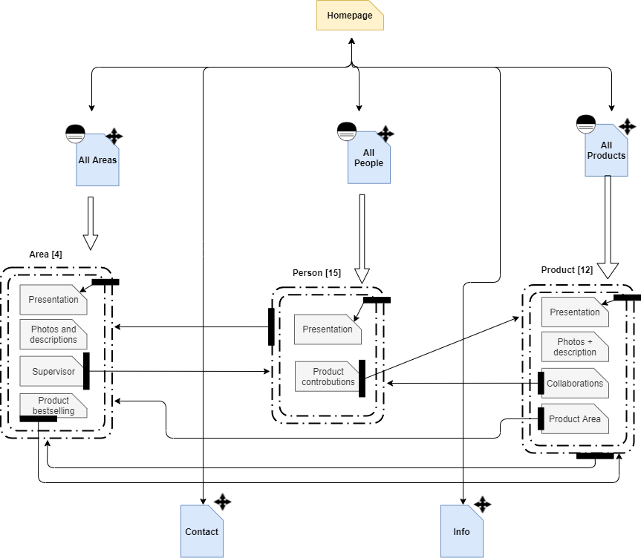

*Figure 2: Page Interactive Dialogue Model*

2.2.1 P-IDM Notes

P-IDM Diagram is an Interactive Dialogue Model, and it is based on C-IDM. It describes the navigational architecture of the website.

We can notice that for each page aggregation (dashed lines in the diagram), the content spans a single physical page in the website. This means that there are no more internal relations we need to highlight: all the links are visible in this main P-IDM Diagram.

1. **Content tables**

Content tables describe the content of our website in the small.

Each component of the C-IDM Diagram corresponds to a table ( see Chapter 2.1 C-IDM Diagram).

|  |
| --- |
| **GROUP OF TOPICS: All areas** |
| ***Title:*** Text (max 20 char)  ***Subtitle:*** Text (max 20 words) |
| ***Items Preview*:**LIST OF [Area image; Area name; Area description]  ***Page description*:** Text (max 100 words) |

|  |
| --- |
| **GROUP OF TOPICS: All people** |
| ***Title*:** Text (max 20 char)  ***Subtitle:*** Text (max 20 words) |
| ***Page presentation*:** <Image, Text (max 100 words)> |
| ***Items Preview*:**LIST OF [Area name, LIST OF (Person image; Person name; Person role)] |

|  |
| --- |
| **GROUP OF TOPICS: All products** |
| ***Title*:** Text (max 20 char)  ***Subtitle:*** Text (max 20 words) |
| ***Items Preview*:**LIST OF [Product image; Product name; Brief Description] |
| ***Development strategies:*** [<Image1, Text>, <Image2, Text>, <Image3, Text>] |

|  |
| --- |
| **KIND OF TOPIC: Areas** |
| ***Area Name****:*Text (max 30 char) |
| ***Area brief description:*** [<Image1, Text>, <Image2, Text>, <Image3, Text>] |
| ***Area long description*:**[Image1, Text1 ( max 300 words), Image2, Text2 ( max 300 words), Image3, Text3 ( max 300 words)] |
| ***Bestselling:*** “Bestselling” |
| ***Bestselling product:*** [Image, Name, Text (max 50 char)] |
| ***Supervisor:*** “Supervisor” |
| ***Area manager:***[Person image; Person name, Person role] |

|  |
| --- |
| **KIND OF TOPIC: Products** |
| ***Product Name****:*Text (max 30 char) |
| ***Product image:*** Image |
| **Product long description:**Text (max 300 words) |
| ***Functionalities section*:** “Functionalities” |
| ***Product functionalities***: [Text1 ( max 50 words), Text2 ( max 50 words), Text3 ( max 50 words)] |
| ***Collaborations section:*** “Collaborations” |
| ***Related Team:***[Area image; Text (max 100 char)] |
| ***Related Area manager:***[Person image; Person name, Person role] |

|  |
| --- |
| **KIND OF TOPIC: People** |
| ***Person anagrafic/image/citation/contribution:*** [Text1 (max 50 char), image, Text2 (max 50 words), Text3 (max 50 words)] |
| ***Contributions title:*** “Contributions”  ***Managed Products:*** LIST OF[Product image; Product name; Text (max 50 char)] |
| ***Form title:*** “Send a message!” |
| ***Contact us /form:*** multipart/ form-data |

|  |
| --- |
| **TOPIC: Contacts** |
| ***Title*:** Contact  ***Contact us/Image:*** Image |
| ***Practical info/addresses/contacts:*** [Text1 (max 50 words), Text2 (max 50 words), Text3 (max 50 words), Text4 (max 50 words)] |
| ***Form title:*** “Contact us!” |
| ***Contact us /form:*** multipart/ form-data |

|  |
| --- |
| **TOPIC: About Us** |
| ***Title*: “**About Us” |
| ***Overview*:** [3 images, Text1 (max 300 words), Text2 (max 300 words), Text3 (max 300 words)] |
| ***Leadership team title:* “**Leadership team” |
| ***Leadership team overview***: [ 3 images, Name1 (max 50 char), Name2 (max 50 char), Name3 (max 50 char), Role1 (max 20 char), Role2 (max 20 char), Role3 (max 20 char)] |

1. **Mapping Content Tables into Pages**

The mapping of the content tables is useful if the content of one or more tables is divided over several pages.

In our case, each table corresponds to a single page of the website.

This chapter would be a repetition of the previous one.

*See chapter 3. Content tables.*

1. **Visual Design (Wireframes and Screenshots)**

Visual Design is dividend in two parts: Low fidelity design and High fidelity design. In Low fidelity design, the initial model of pages is presented and all links are highlighted. In High fidelity design, the final design of pages is showed by to screenshot.

According to project specifications, wireframes have been created only for the main pages. Main pages are:

* Home Page
* One Topic page (we have chosen two topic pages: AboutUs and Contact)
* Every kind of Topic pages
* Three introductory pages for groups (we have chosen Areas, Products and People)
  1. Commented low fidelity wireframes

Low fidelity wireframes show the base structure of pages: fixed Header on the top, fixed Footer on the bottom and variable content in the middle. They also highlight links (where links are and which is their category) and the orientation information (in order to understand where user in the website).

Link’s Categories are:

* **transition links**: allow the user to move from a page of a given topic to a page of a different topic that have a semantic relationship with it (e.g., from the product page to the related area)
* **group links**: enable the user to move across the elements of a group, e.g., from the introductory page of a group (in which there is the list of all components)
* **landmark links**: are those available in all pages ( e.g., menu fixed in the header)



These are the low design wireframes:

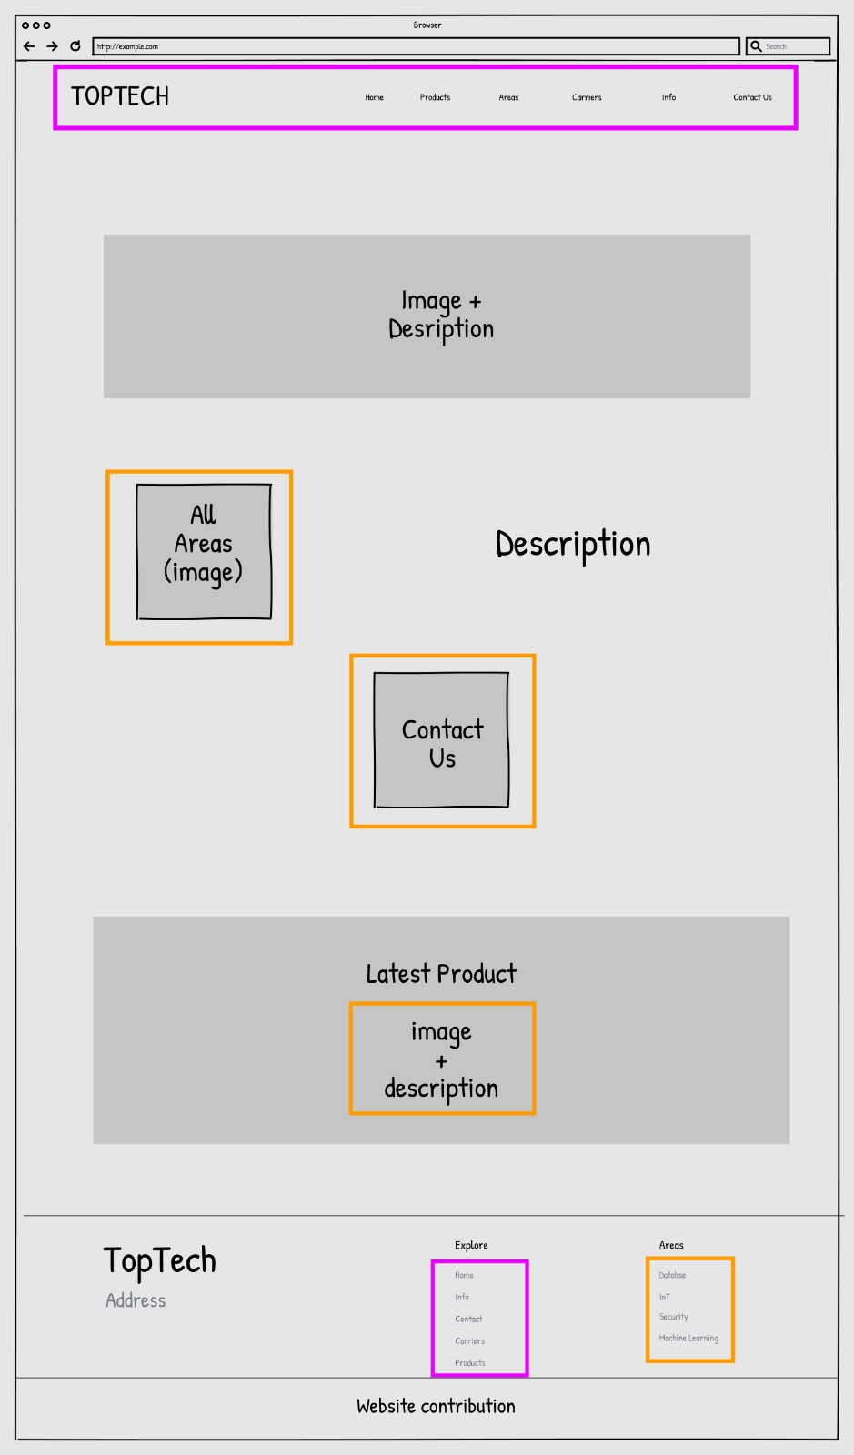

*Wireframe 1 _Homepage*

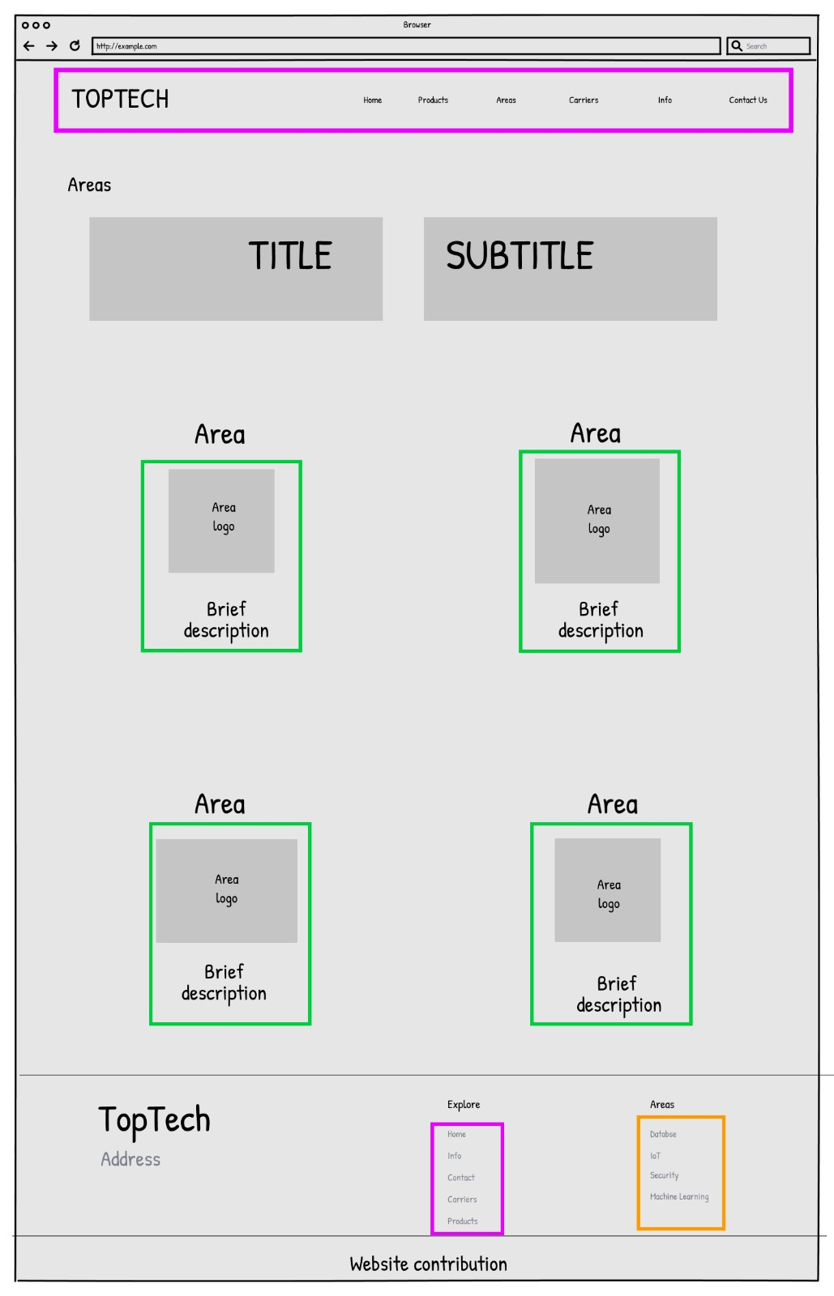

*Wireframe 2 _All Areas*

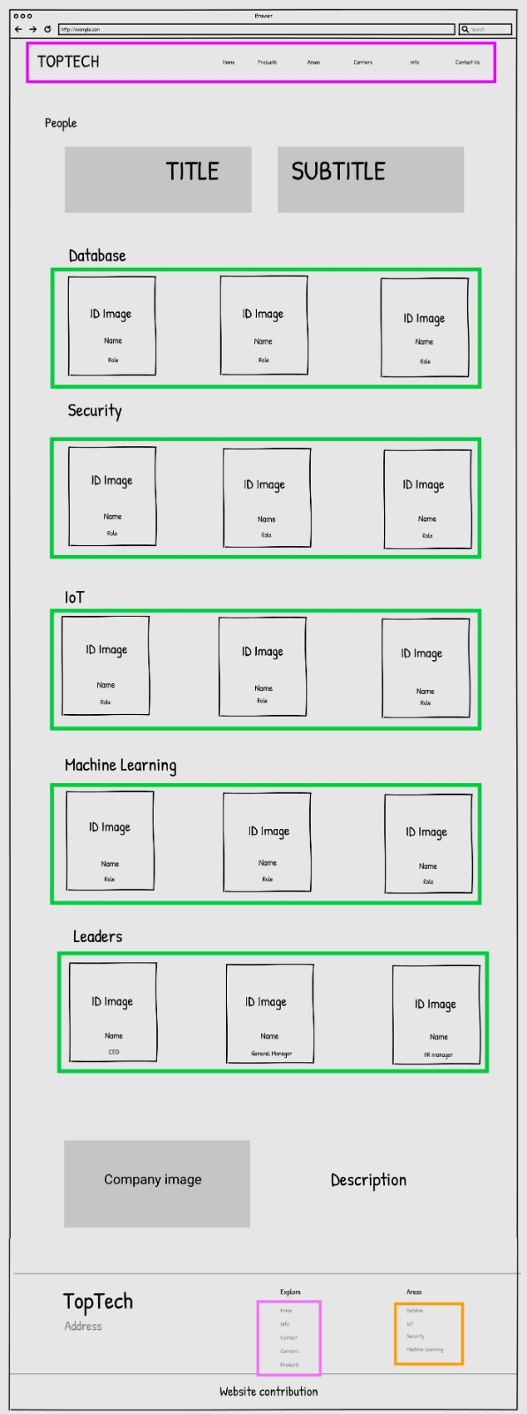

*Wireframe 3 _All People*

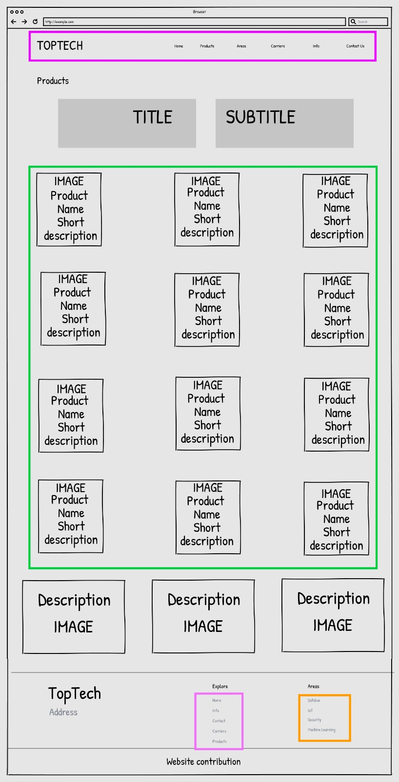

*Wireframe 4 _All Products*

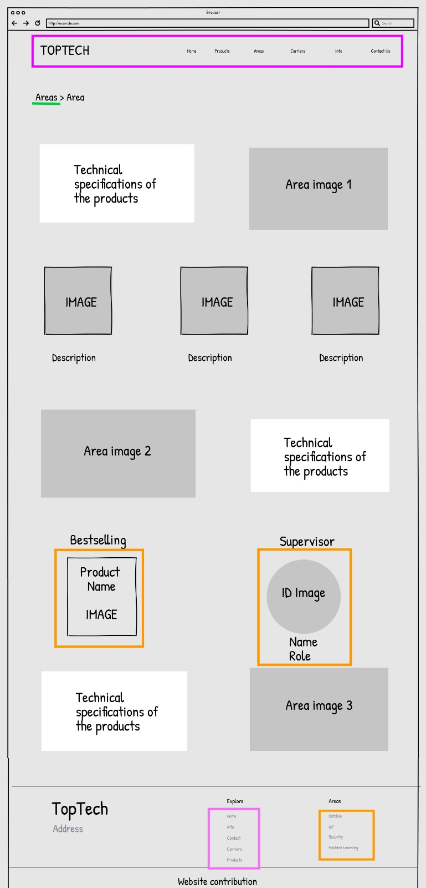

*Wireframe 5_ Kind of Topic Area*

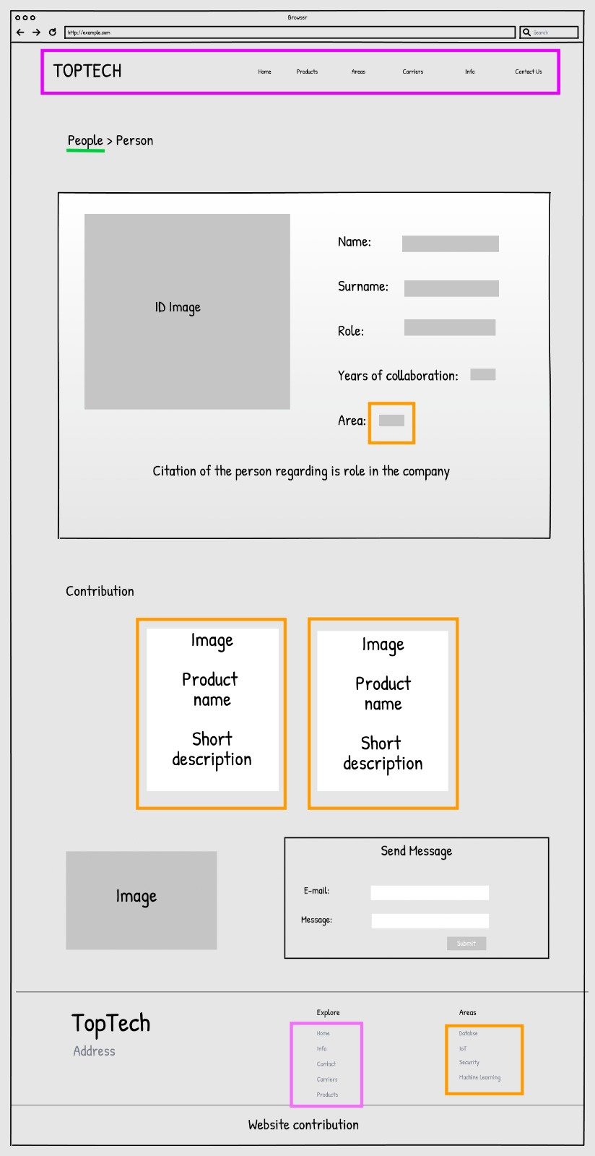

*Wireframe 6_ Kind of Topic Person*

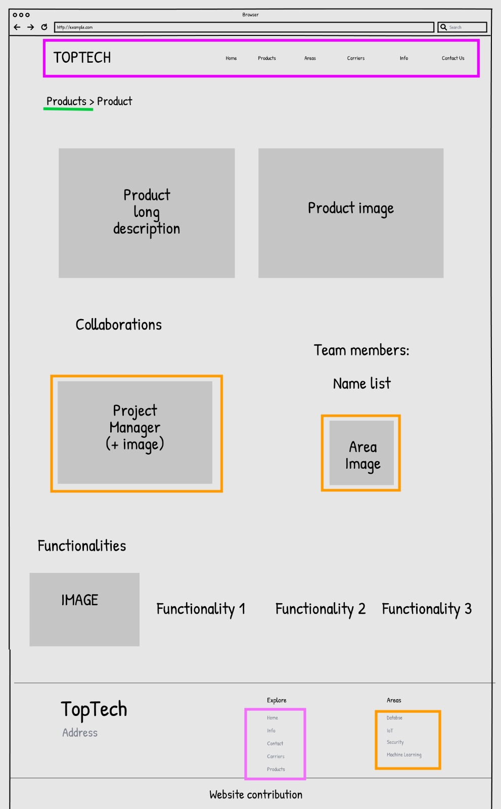

*Wireframe 7_ Kind of Topic Product*

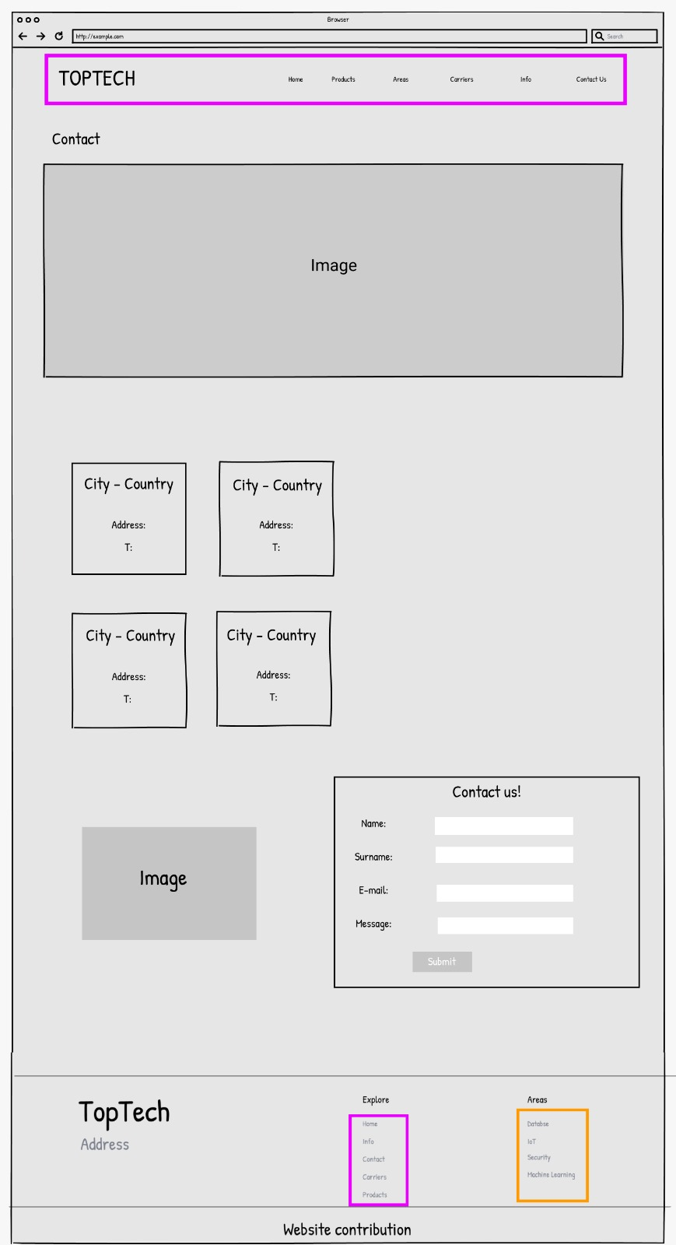

*Wireframe 8_ Topic Contact*

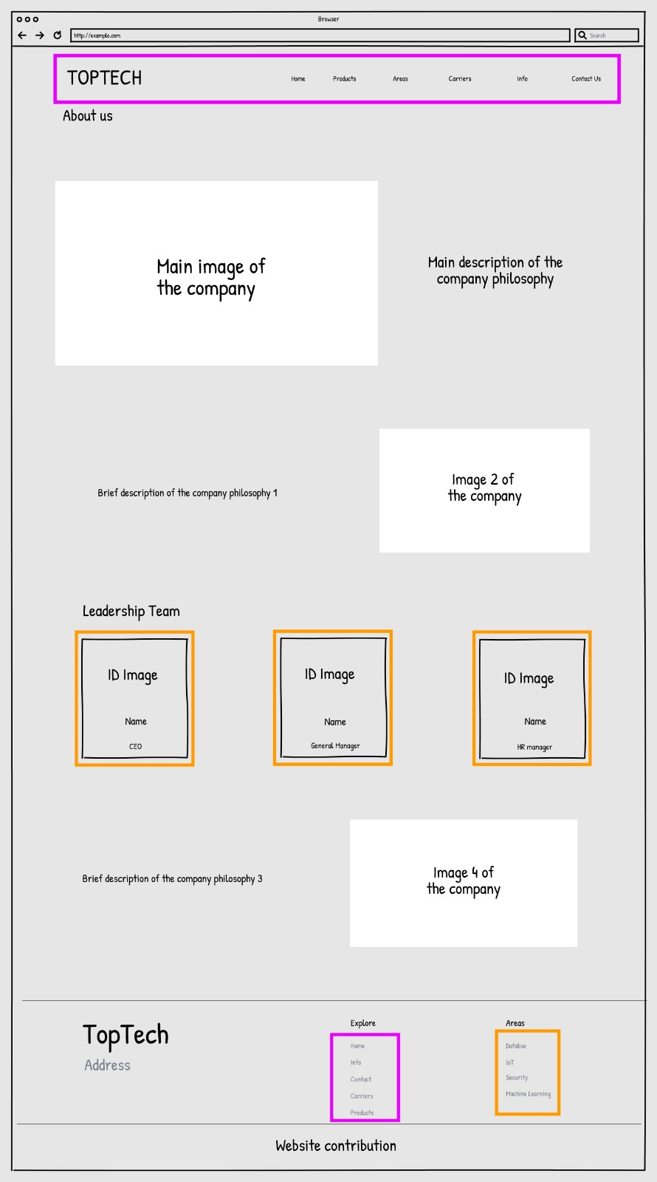

*Wireframe 9_ Topic AboutUs*

* 1. Commented high fidelity wireframes

While the wireframes allowed an approximate visualization of the design, screenshots show the final version of the main pages of our website. Screenshots refer to the same pages as the wireframes with the addition of the Homepage one.

HOMEPAGE

Header and Footer (they will be the same for all the other pages, for this reason, they contain LANDMARKS). Links clickable by the user in the Header are: HOME and the LOGO of the Company to go back home, the links refering to the groups of Topics AREAS, PRODUCTS and PEOPLE and the topics ABOUTUS and CONTACTS.

In the Footer there are the same links of the header regarding the group of topics and topics but with the addition of the links for the AREA Kind of topics.

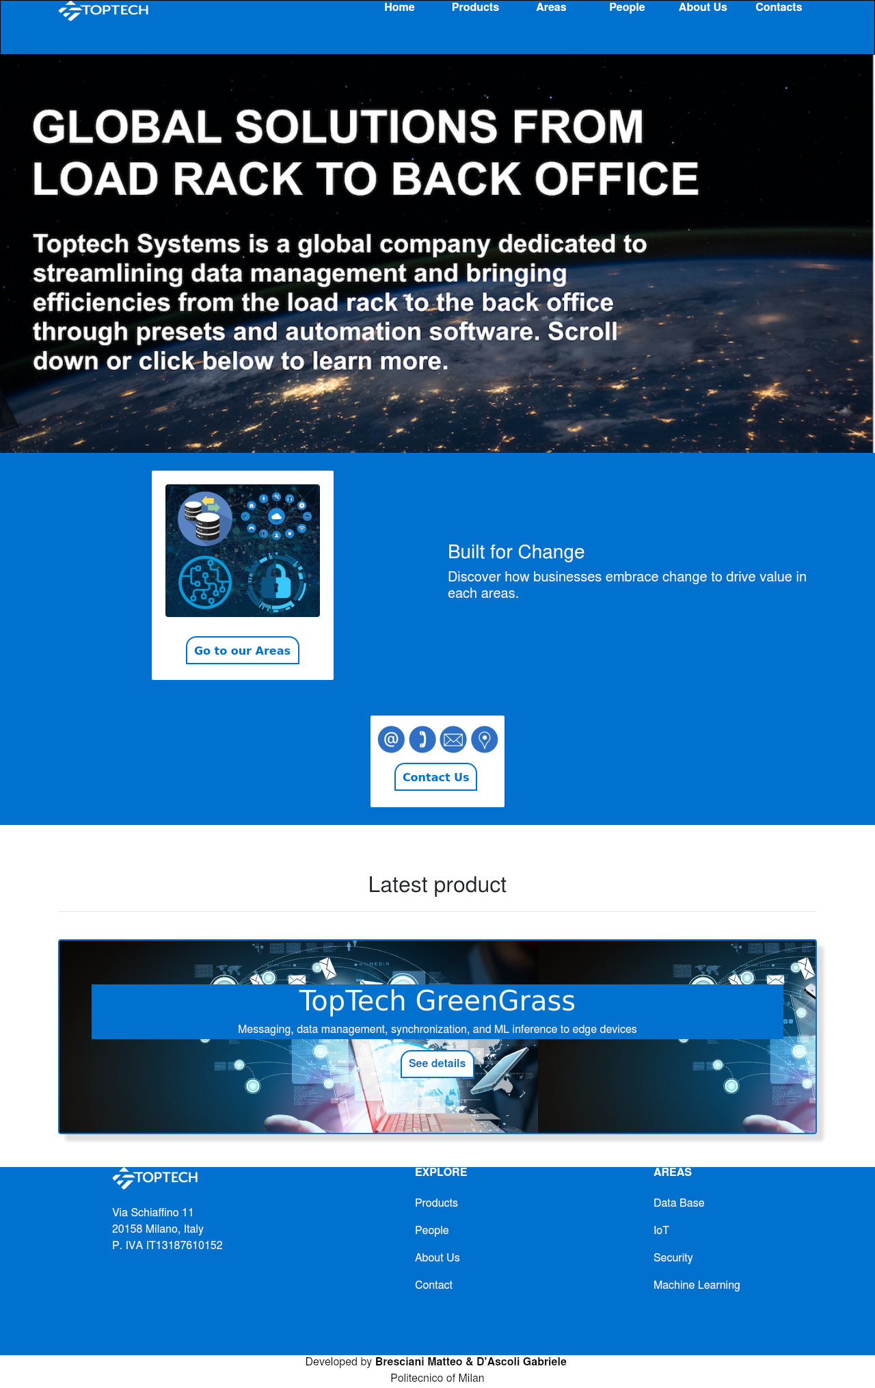

*Wireframe 10 _Home page*

GROUP OF TOPICS: ALL AREAS This is the introductory page for Areas and it contains the list of them. Every image is a GROUP LINK that allows user to open and read specific information about it.

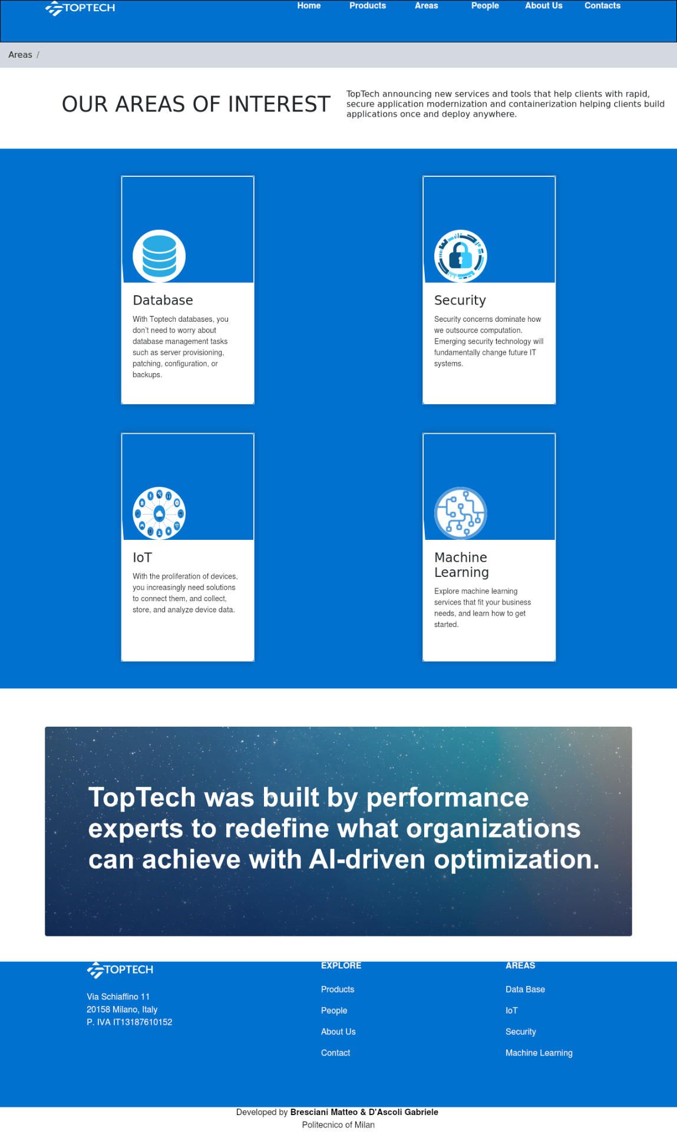

*Wireframe 11_ All Areas*

GROP OF TOPICS: ALL PRODUCTS This is the introductory page for products and it contains the list of them. Every image is a GROUP LINK that allows user to open and read specific information about it or to go to related areas.

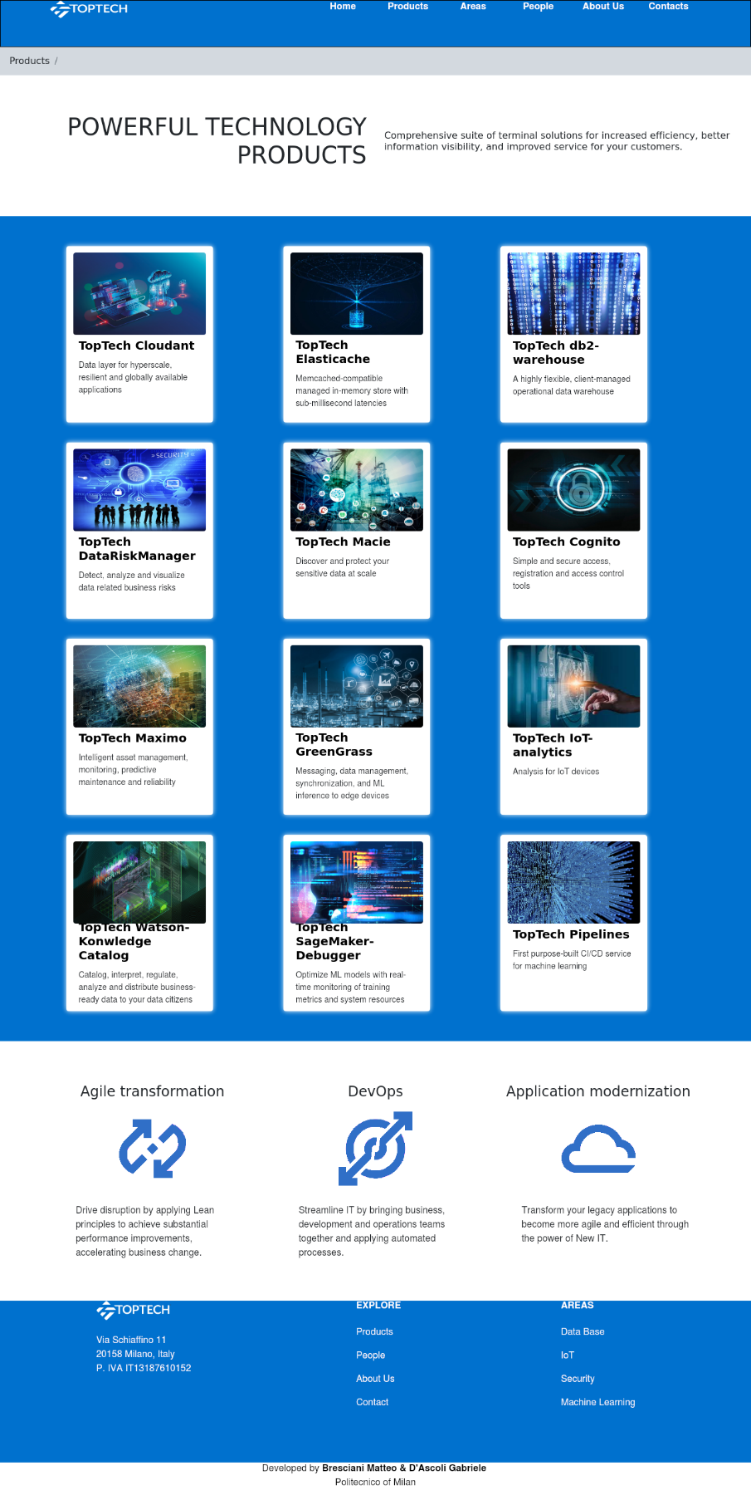

*Wireframe 12 _All Products*

GROUP OF TOPICS: ALL PEOPLE This is the introductory page for people and it contains the list of them. Every image is a GROUP LINK that allows user to open and read specific information about people who working in the company.

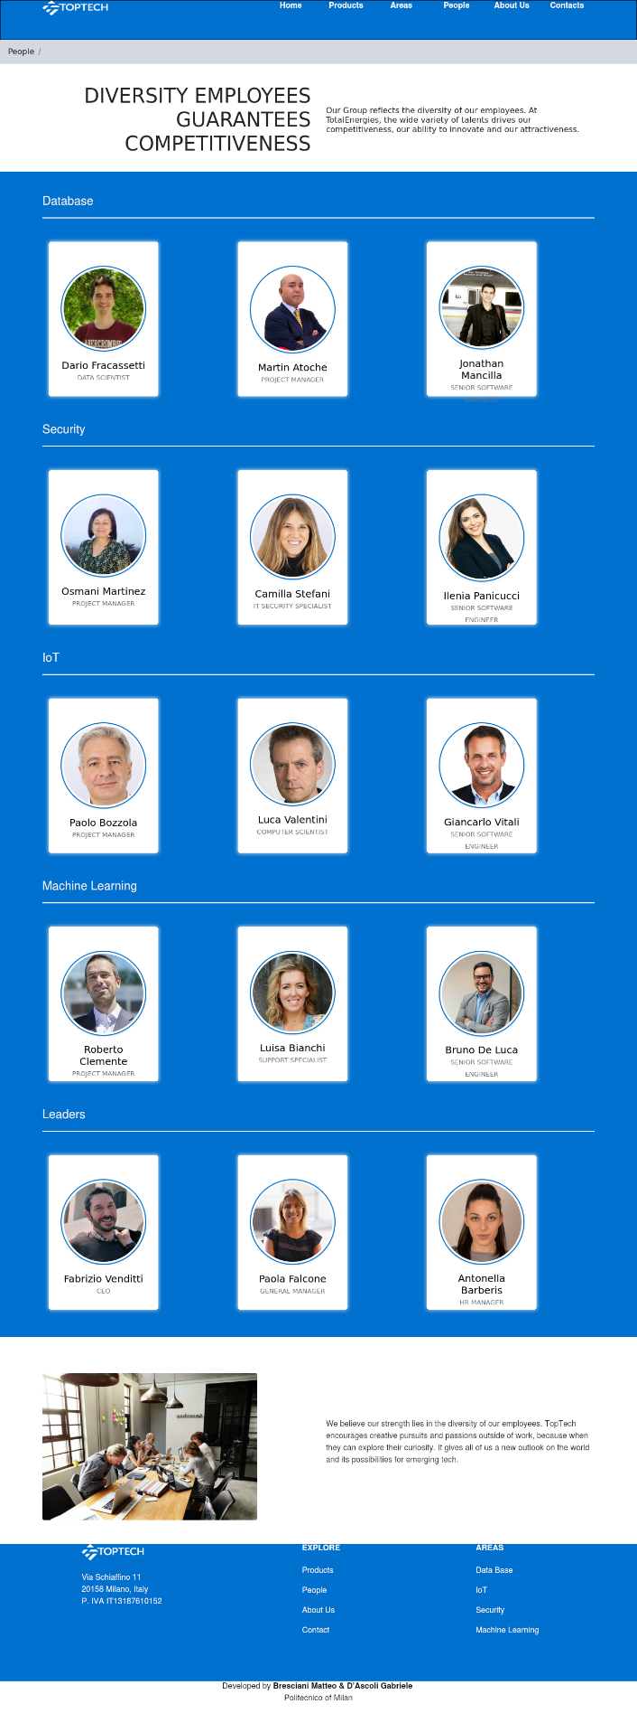

*Wireframe 13 _ All People*

KIND OF TOPIC: Area This page contains the explanation of one Area and the TRANSITION LINKS to move to related products and to Person who managed this Topic. On the top of the page there is the Orientation Information fo the user.

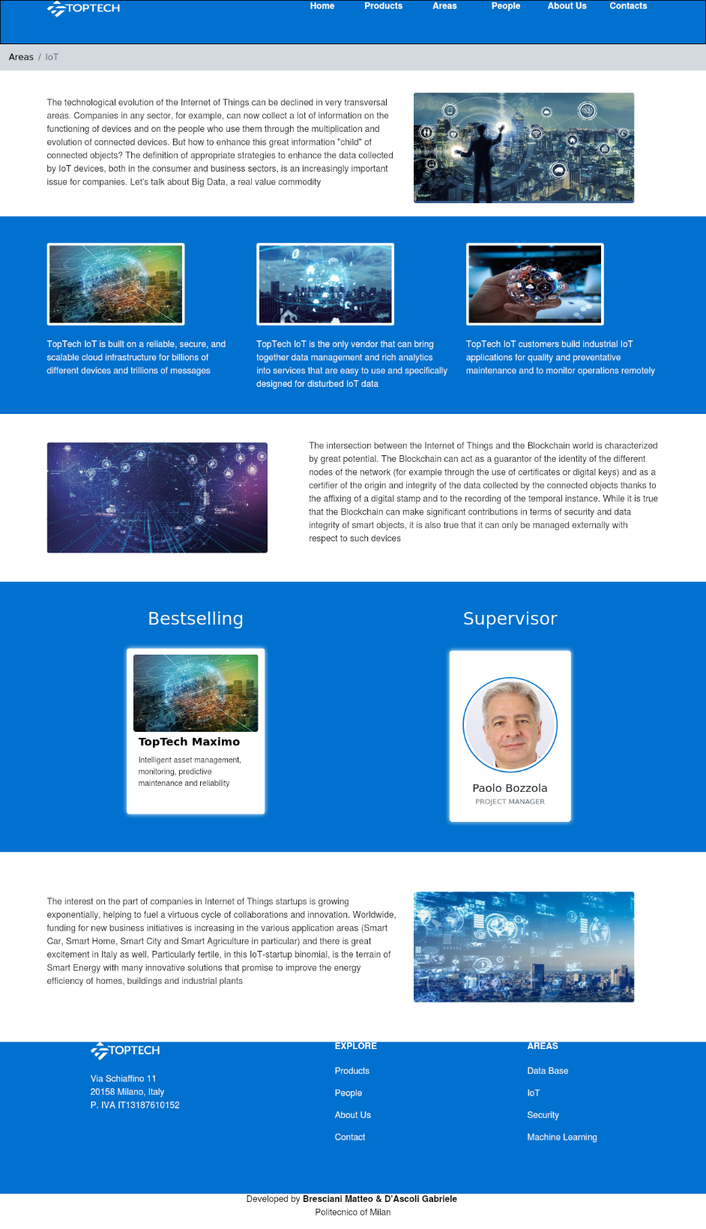

*Wireframe 14 _Kind of topic Area*

KIND OF TOPIC: Product This page contains the explanation of one Product and the TRANSITION LINKS to move to related Area and to Person who managed this Topic. On the top of the page there is the Orientation Information fo the user.

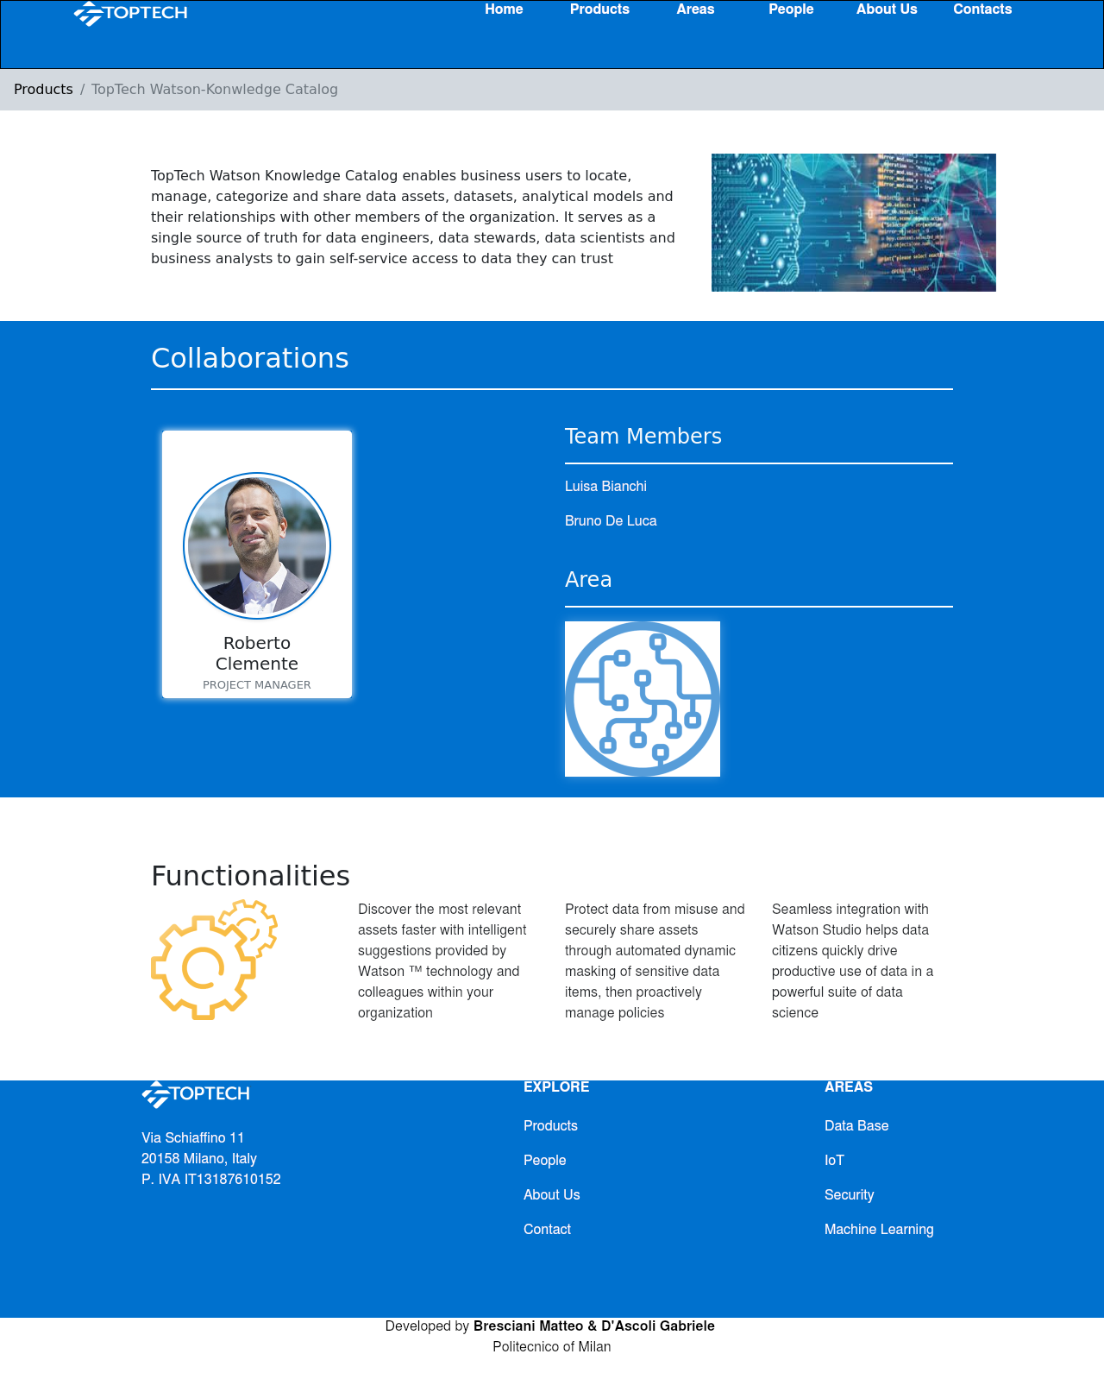

*Wireframe 15 _Kind of Topic Product*

KIND OF TOPIC: Person This page contains the explanation of one Person and the TRANSITION LINKS to move to related Area and to managed Products. On the top of the page there is the Orientation Information fo the user.

The page contains also a Contact FORM that the user can use to keep in touch directly with the person.

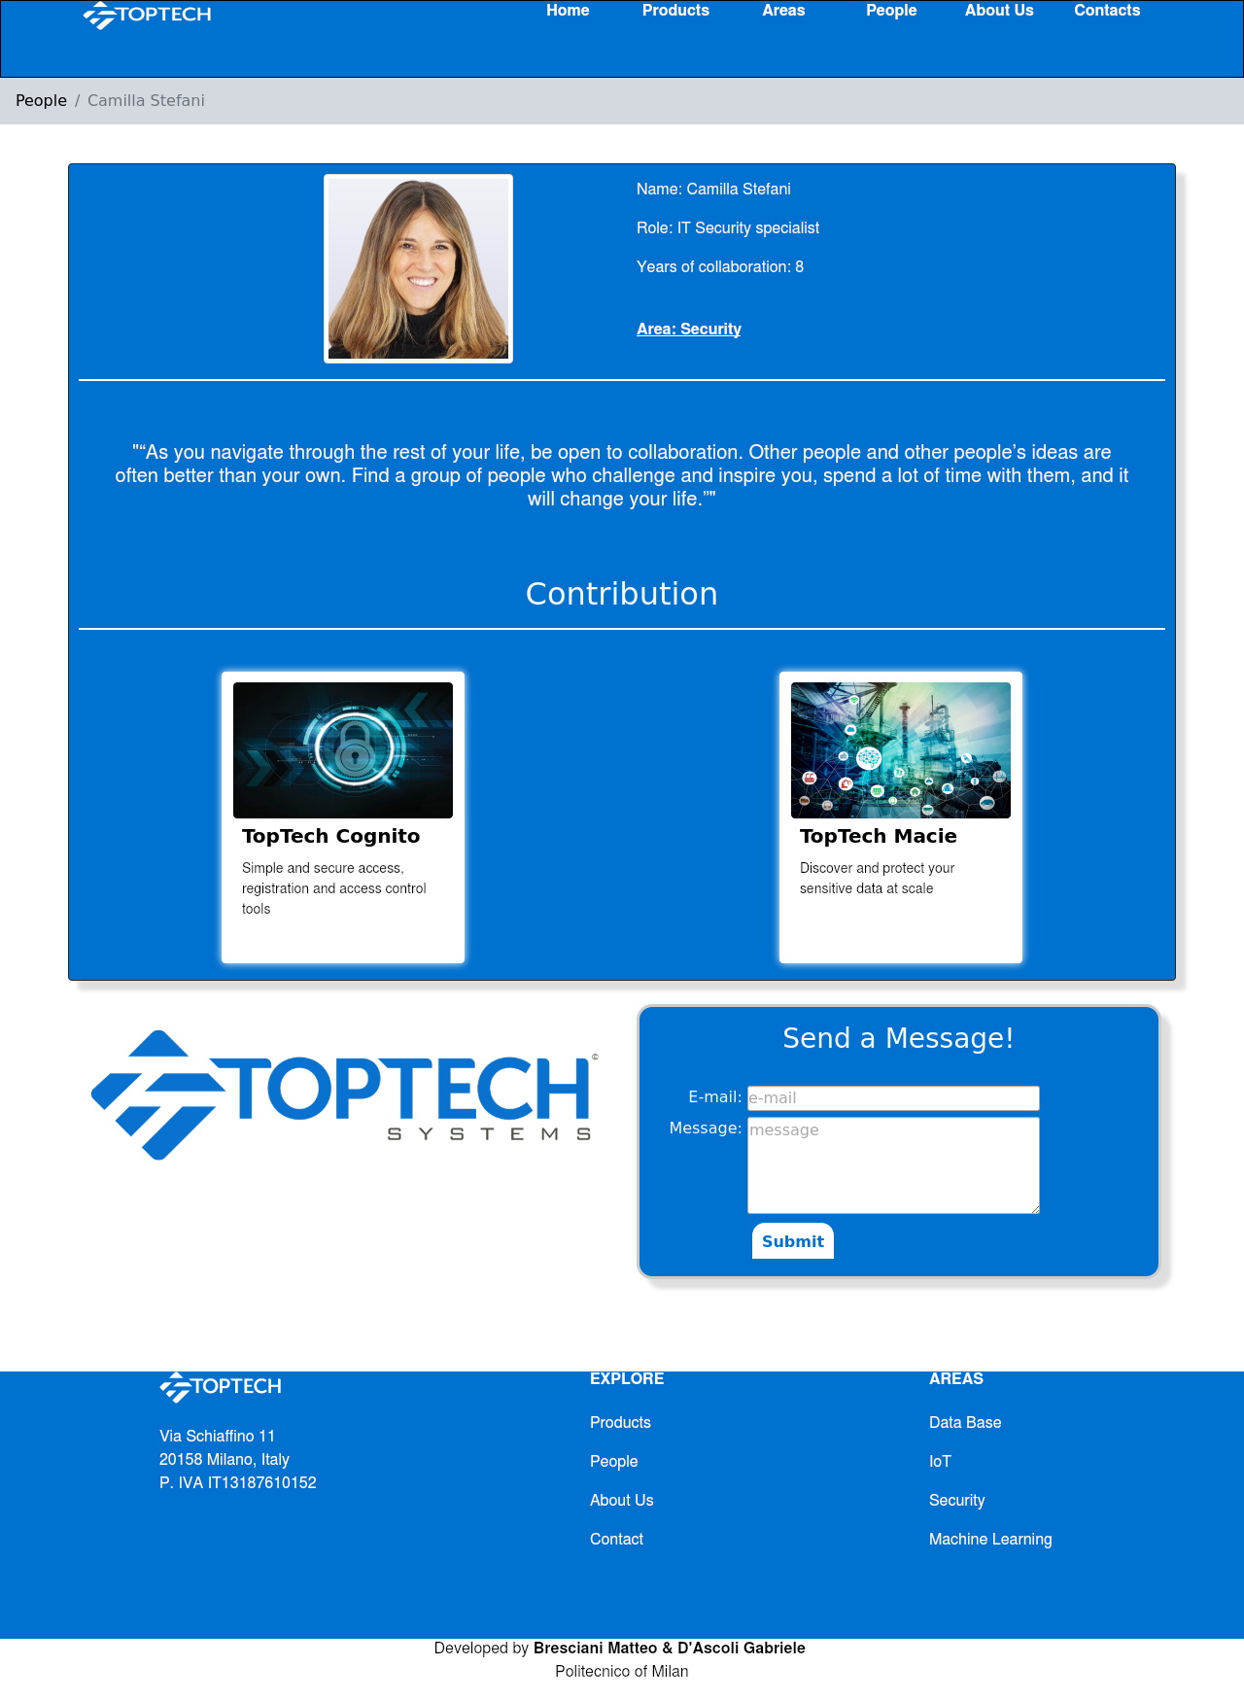

*Wireframe 16 _Kind of Topic: Person*

TOPIC: Contact

This page contains the list of Contacts of all the company offices. The page contains also a Contact FORM that the user can use to keep in touch with the company.

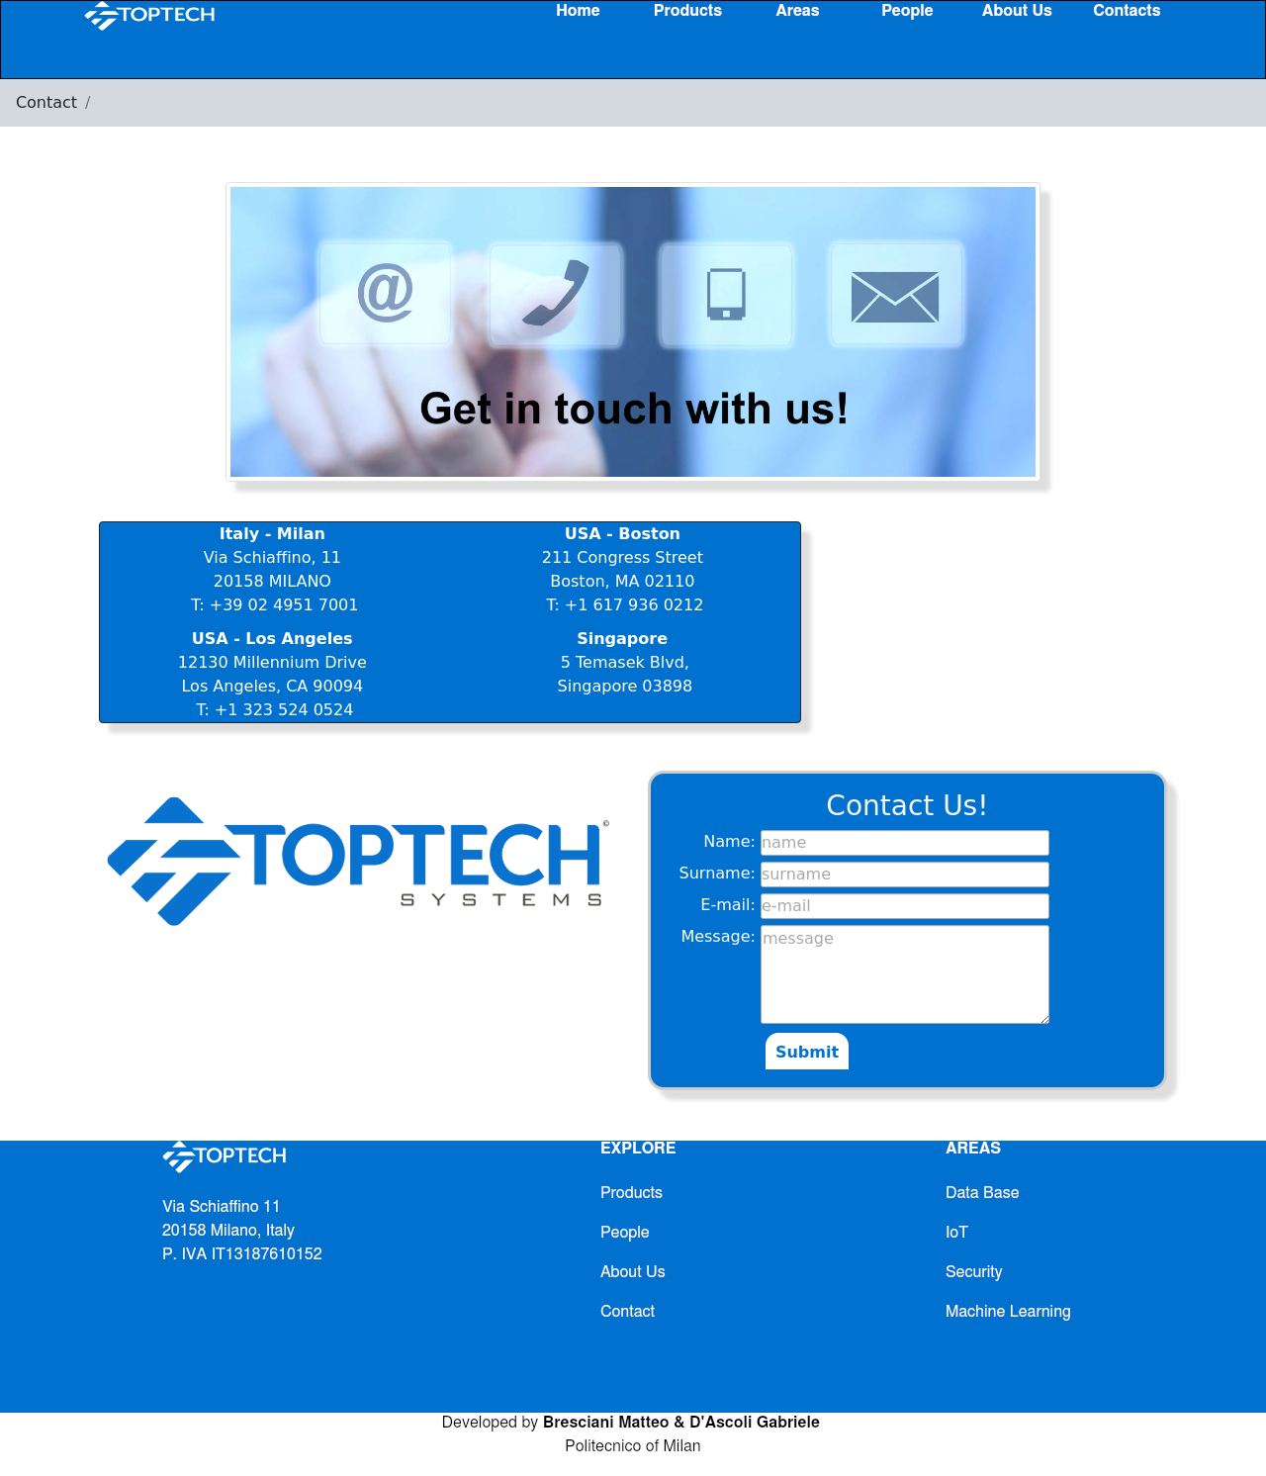

*Wireframe 17 _ Topic: Contact*

TOPIC: About us This page contains information about history, philosophy and the scope of the company. There are TRANSITION LINKS that allow user to visit the Person pages of the leadership team’s members of the company, in order to read who manage the ICTea.

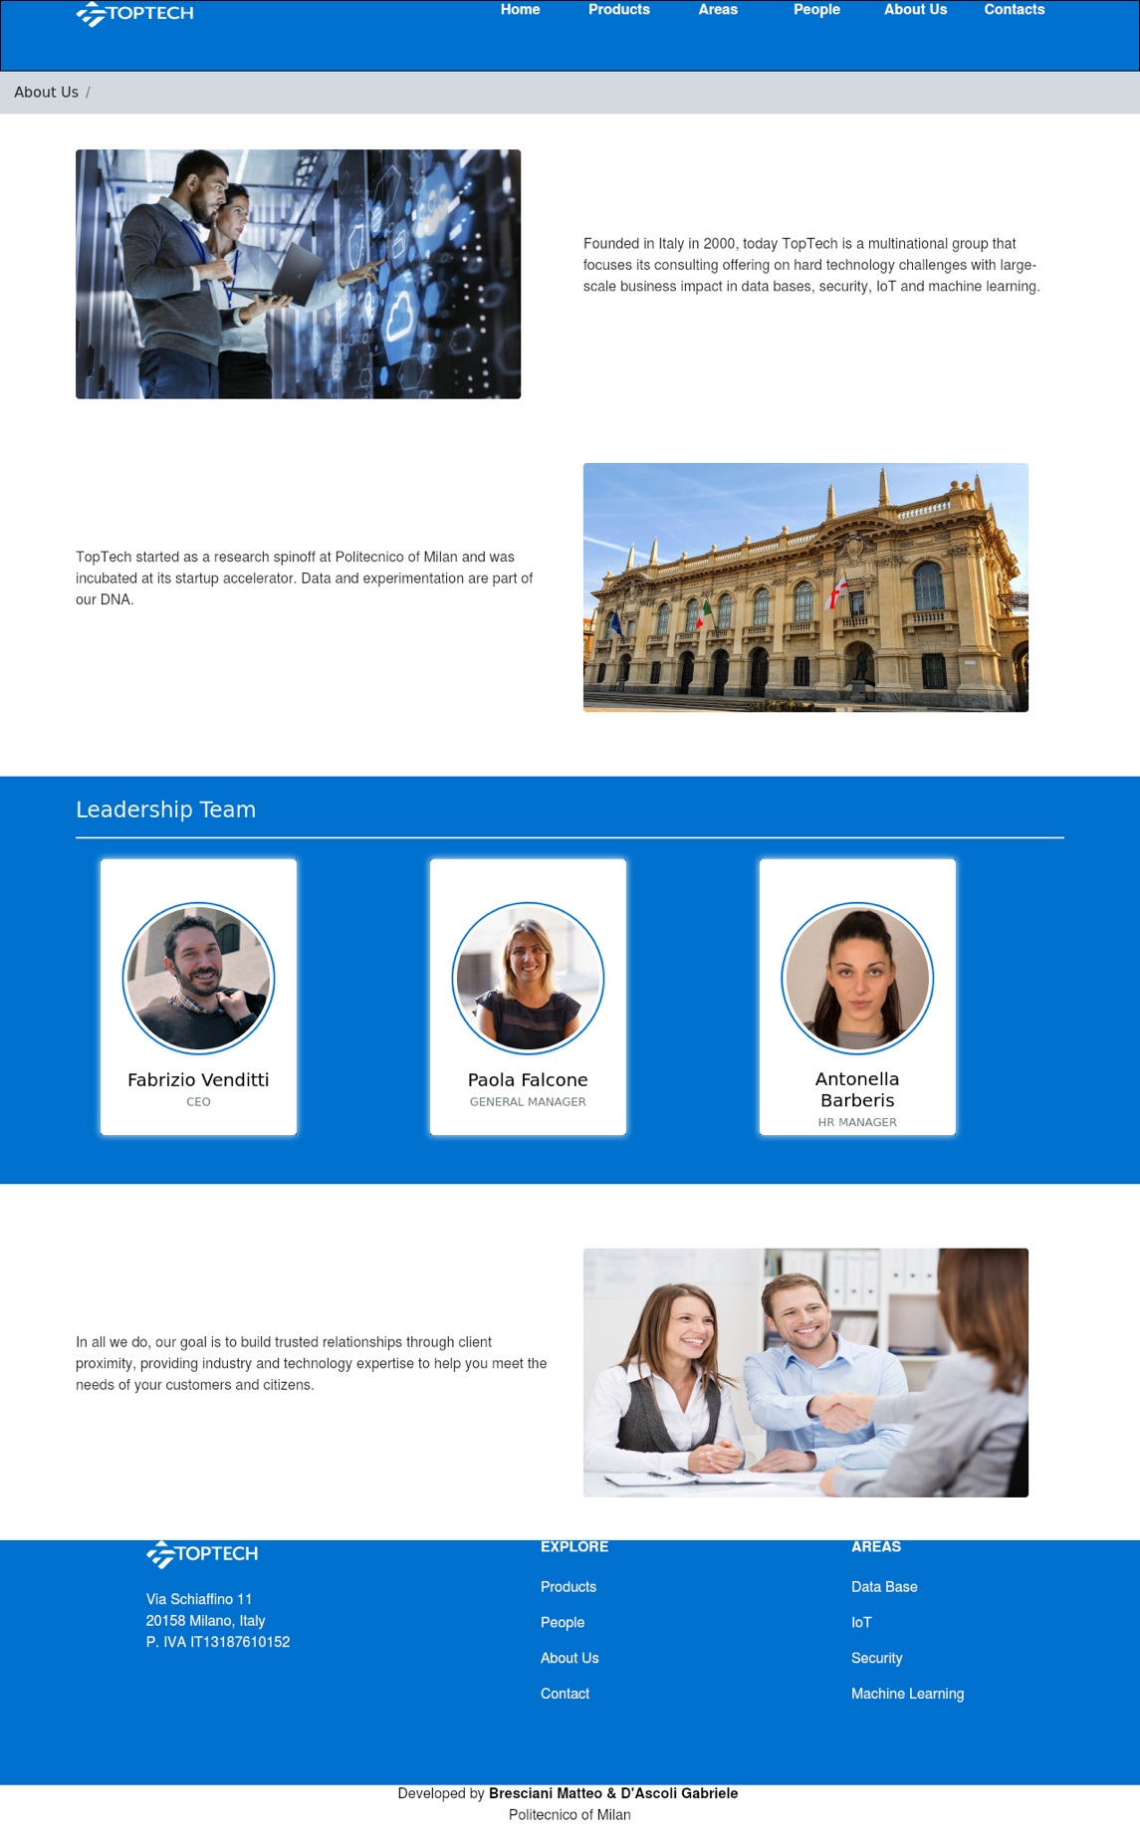

*Wireframe 18 _Topic About us*

1. **Scenarios**

The following chapter will focus on the presentation of general scenarios, which are “a narrative description of what people do and experience as they try to make use of computer systems and applications” (M. Carrol, “Scenario-based Design”, Wiley, 1995); each scenario describes a possible usage of the web site by the users in real life and presented in order of complexity.

6.1 Case 1

6.1.1 Textual narrative

**User profile**: a graduating computer engineer is looking for a company that will give him the opportunity to do an internship in the software development sector after graduation.

**Goals**: the user wants to contact the company to get information on vacant positions and to give his availability.

**Context**: the user visits the TopTech company website during a study break, looking for a way to submit his application.

**Tasks**: the user navigates through the sections of the website, accesses the Contacts section and fills out the appropriate form to communicate with the company by entering his data.

6.1.2 Sequence

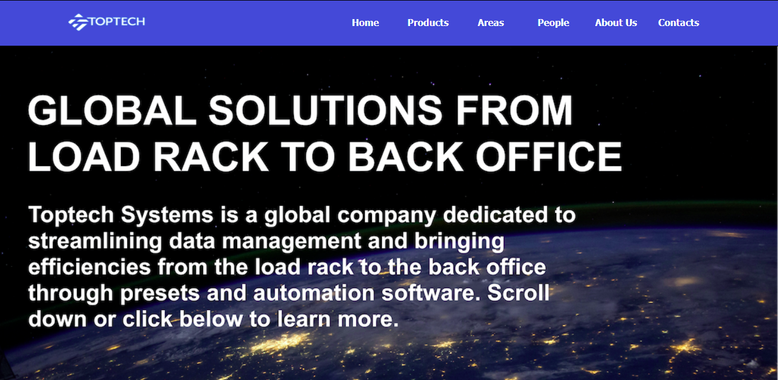

*Figure1. User visits the TopTech website and selects Contact*

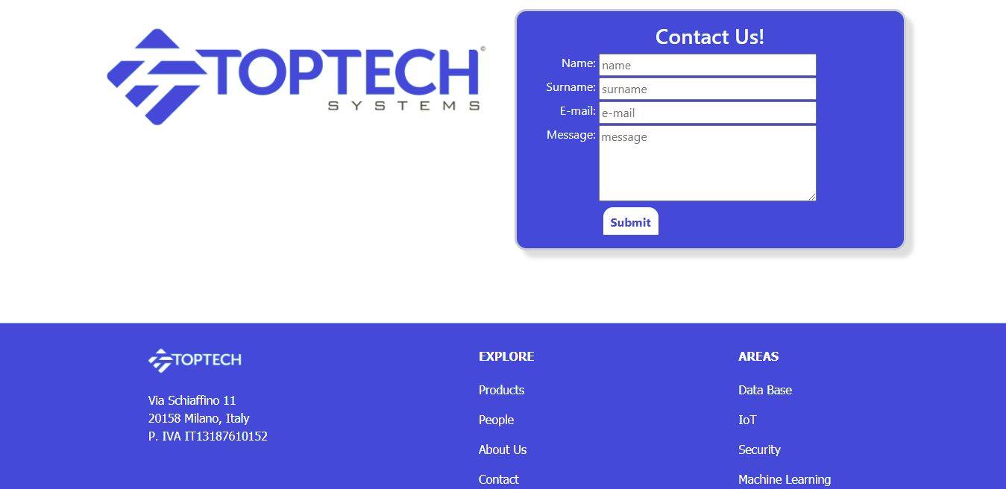

*Figure2. User visualize the Contact page and find the Contact form*

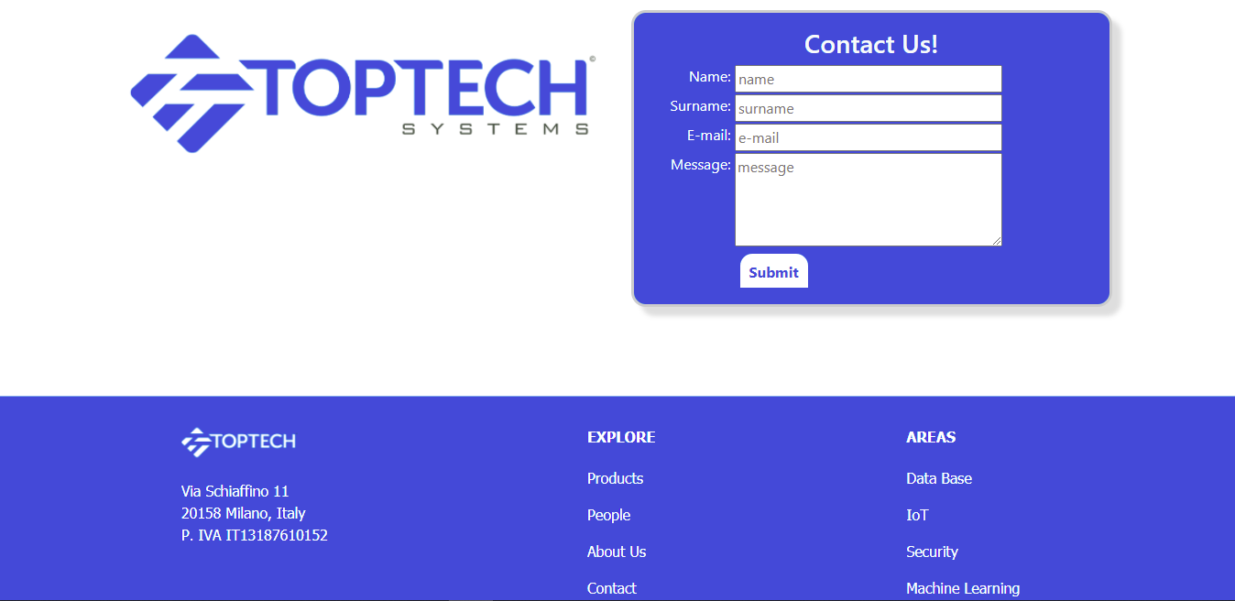

Figure 3. User fills the form with the required information and clicks Submit to send the request

6.2 Case 2

6.2.1 Textual narrative

**User profile**: a scientific informant in the IT sector is carrying out an IT company monitoring campaign on behalf of a company that deals with market analysis.

**Goals**: the user acquires information from the company's website about the best-selling product in the IoT sector among those proposed by the TopTech company.

**Context**: the expert within the monitoring campaign for which he is collaborating visits the TopTech website in search of the data he needs for his market analysis.

**Tasks**: the user visits the website of the TopTech company, navigates between the various sections and accesses the one relating to the treated areas; once you have chosen the IoT area you are interested in, you can view the bestselling product in that area and the page relating to it with all its technical specifications and functionalities.

6.2.2 Sequence

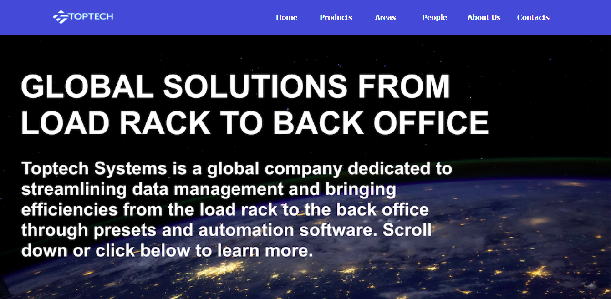

*Figure 4. The expert visits the TopTech Company website and select Areas to access to the interested area*

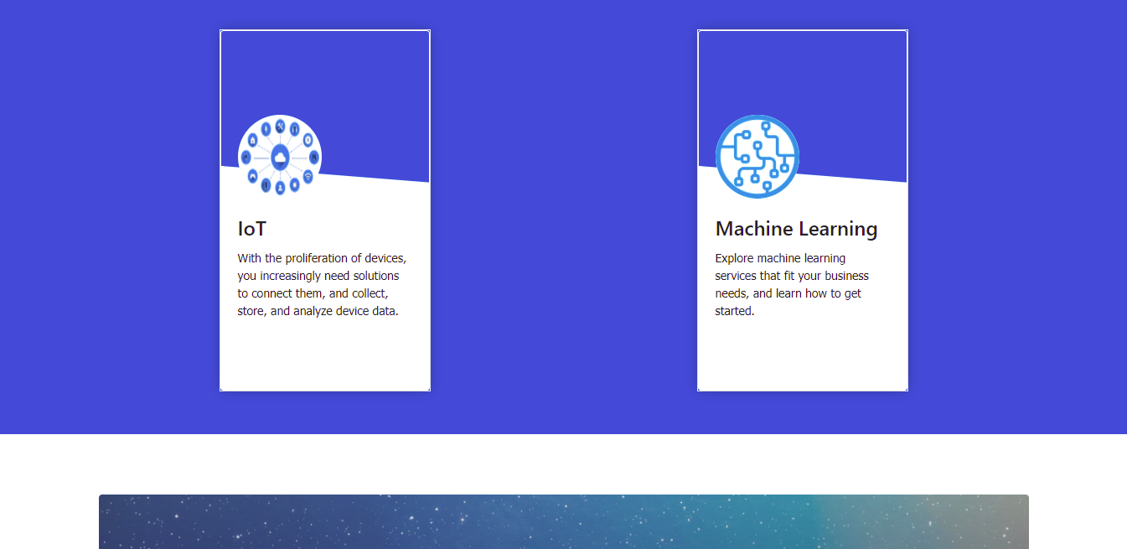

*Figure 5. Once accessed to Areas section the user search and clicks on the IoT area*

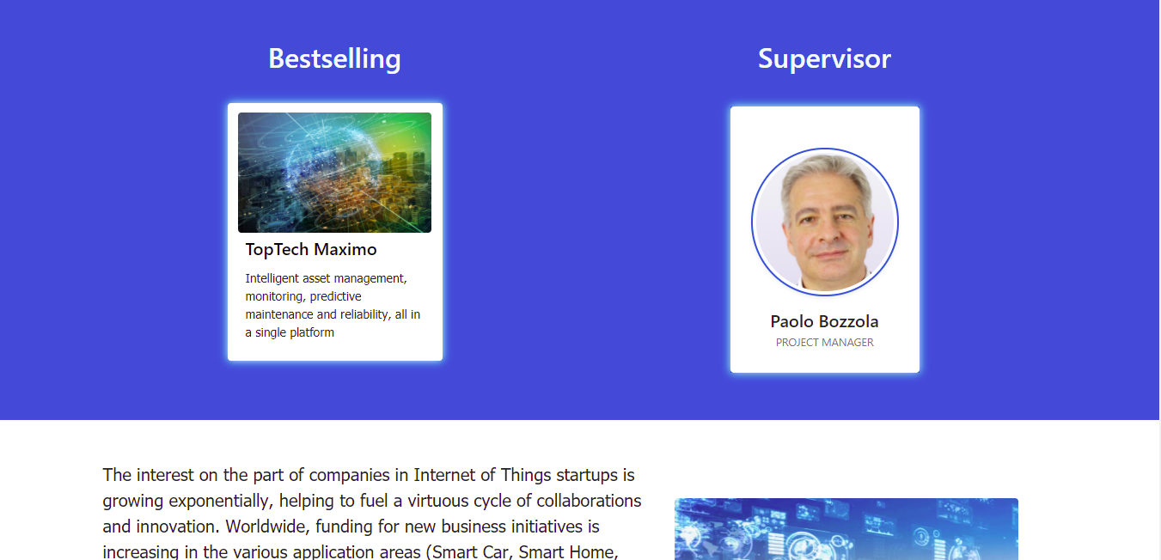

*Figure 6. Scrolling down in the relative page the user visualize the Bestselling of the Area and click on it*

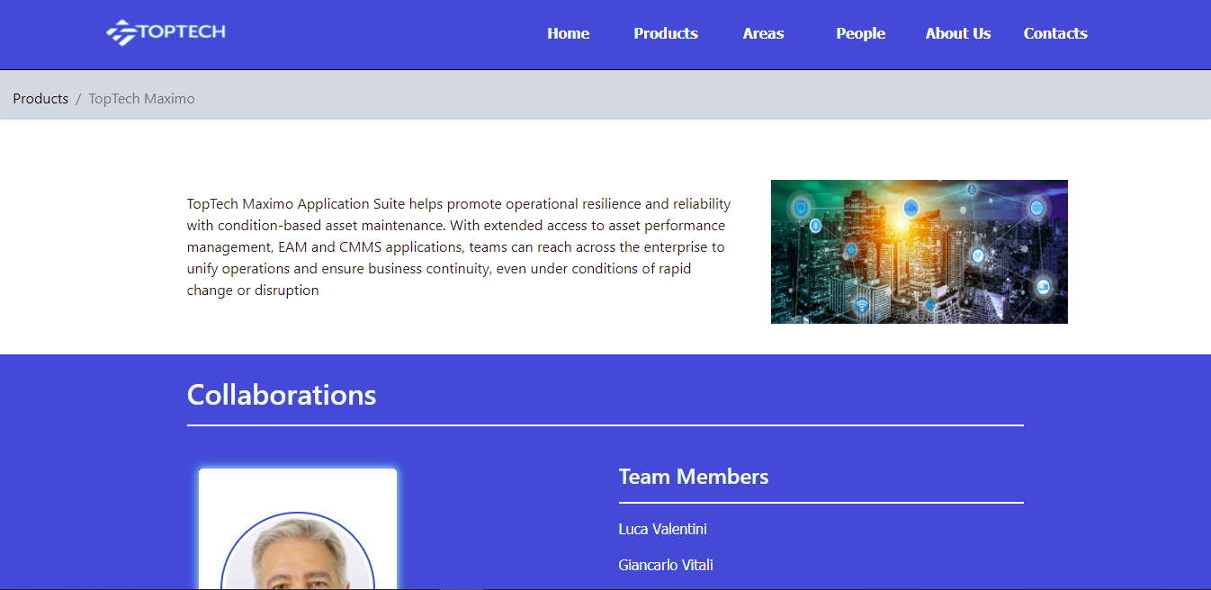

*Figure 7. The user so access to the page of the Product and find all the related information*

6.3 Case 3

6.3.1 Textual narrative

**User profile**: the data processing manager of a bank branch is testing a new TopTech Security IT sector product and is unable to fully utilize a particular feature.

**Goals**: the customer wants to contact the TopTech project manager responsible for product development to ask him for clarification on the use of the purchased product.

**Context**: the data processing manager, approaching the use of the new product at his workplace with data relating to the bank's customers, visits the TopTech website in search of information regarding the development team of the purchased product and a way to contact the project manager directly.

**Tasks**: the customer visits the website of the TopTech company, navigates between the sections of the site and accesses the Products section; at this point he searches for the purchased product among those offered by the company, accesses its relative page within which he will find the person at the head of the research team. At this point, the customer accesses the project manager's card and, by entering their data, uses the appropriate contact form to interact directly with the manager and expose the matter to him.

6.3.2 Sequence

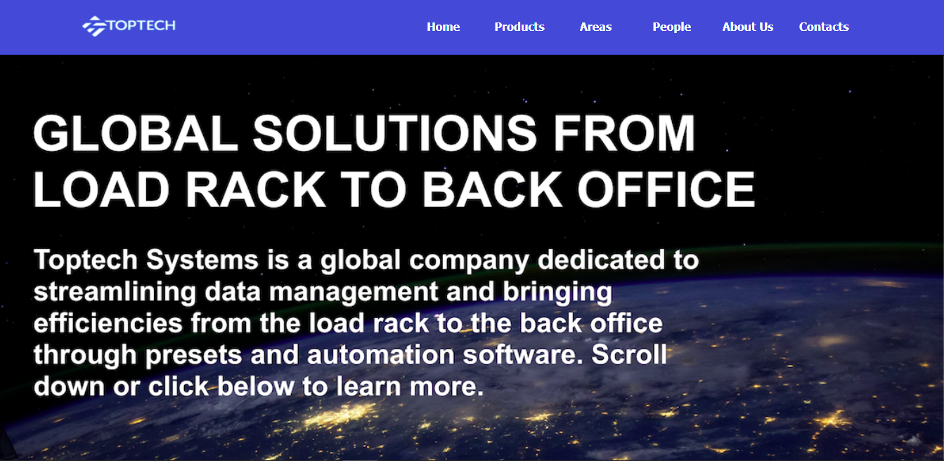

*Figure 8. The customer visits the Website of the TopTech company and select the Products section*

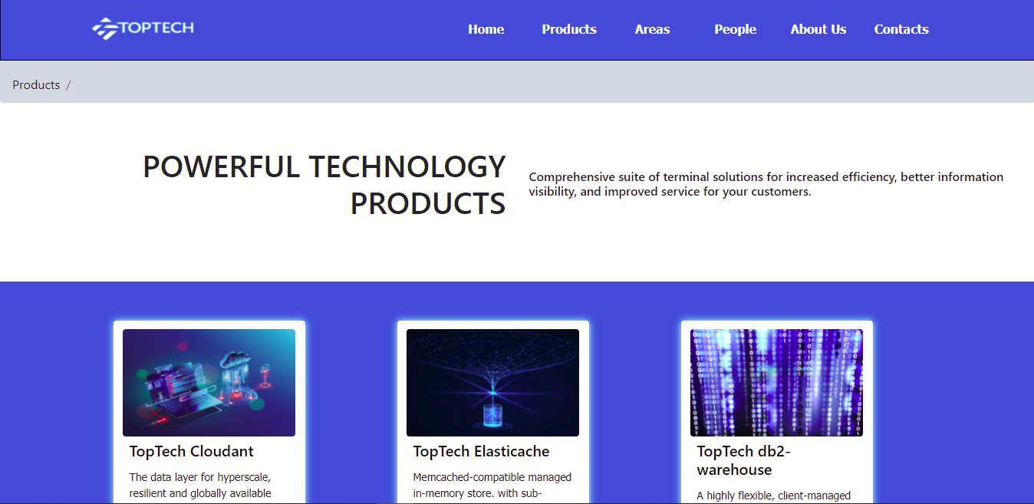

*Figure 9. The user access to the page containing all the TopTech products*

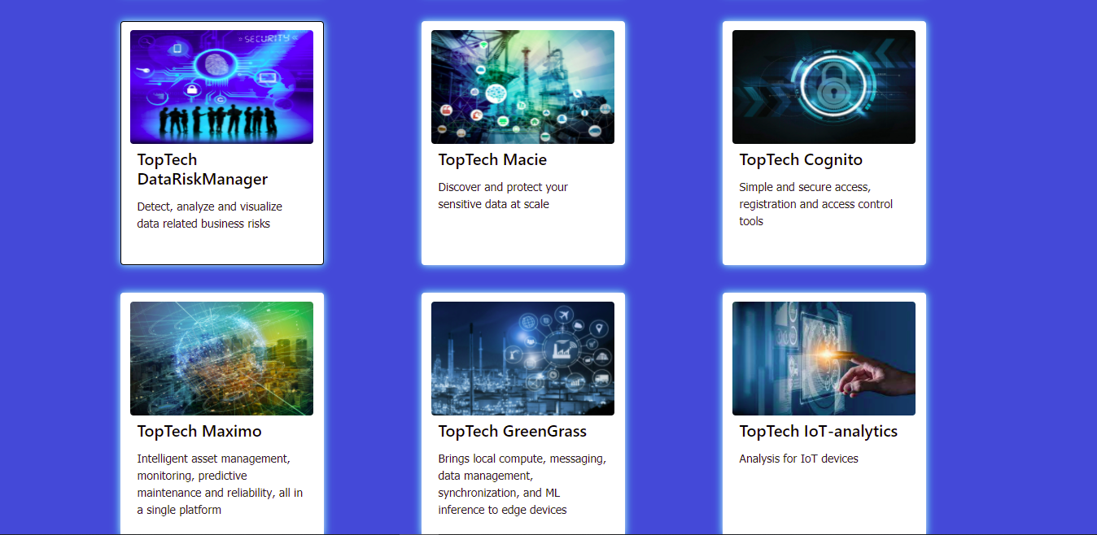

*Figure 10. Scrolling down in the page the customer finds and clicks on the purchased product*

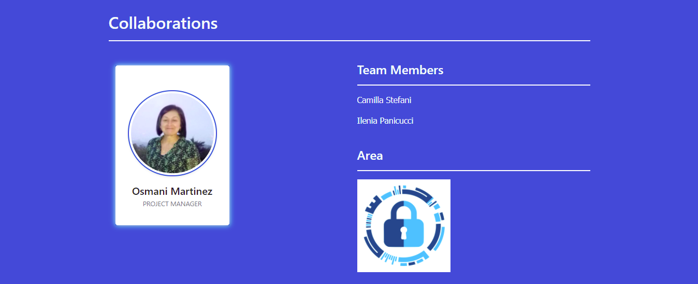

*Figure 11. Once accessed to the relative page the user visualize and clicks on the person leading the team*

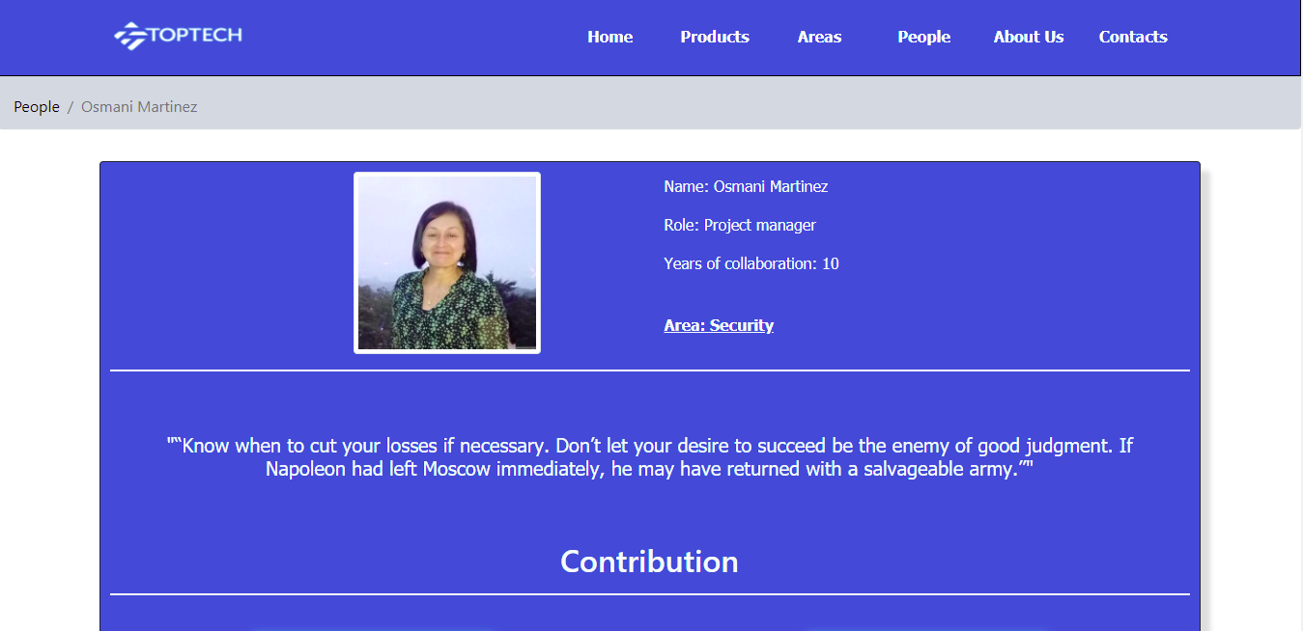

*Figure 12. The customer enters into the personal page of the Project Manager*

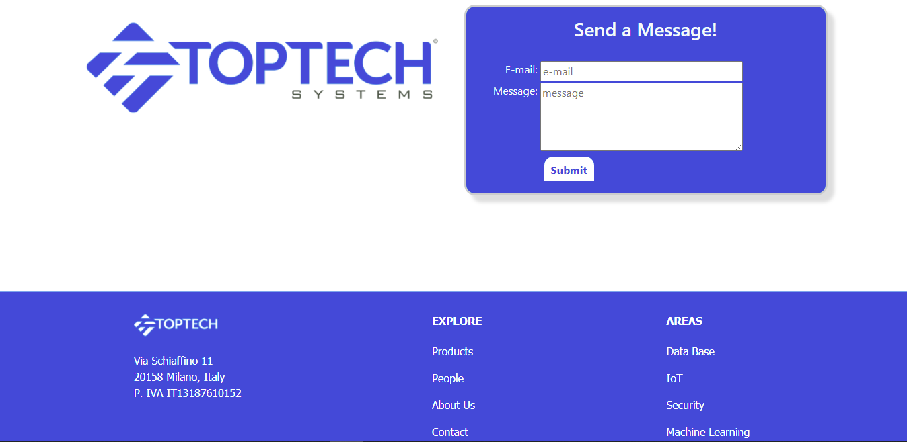

*Figure 13. In this page the customer uses the form to keep in contact directly with the person in charge*

1. **DB Design**
   1. Relational tables

For our WebApp we saved informations into Databases to keep them stored in an organized way and we have used PostgreSQL as DBMS.

We created a DB for: the service Area (tab 8.1), Product (tab 8.2), Person for the people working in ICTea (tab 8.3) and AboutUs (tab 8.4). We have also initialized databases which will then be filled in by the user for the ContactUs (tab 8.5) sections.

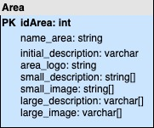

*Tab 8. 1*

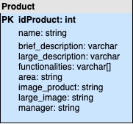

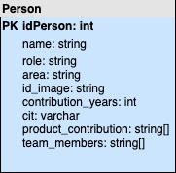

*Tab 8. 3*

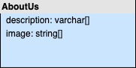

*Tab 8. 4*

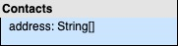

*Tab 8. 2*

*Tab 8. 5*

* 1. ER

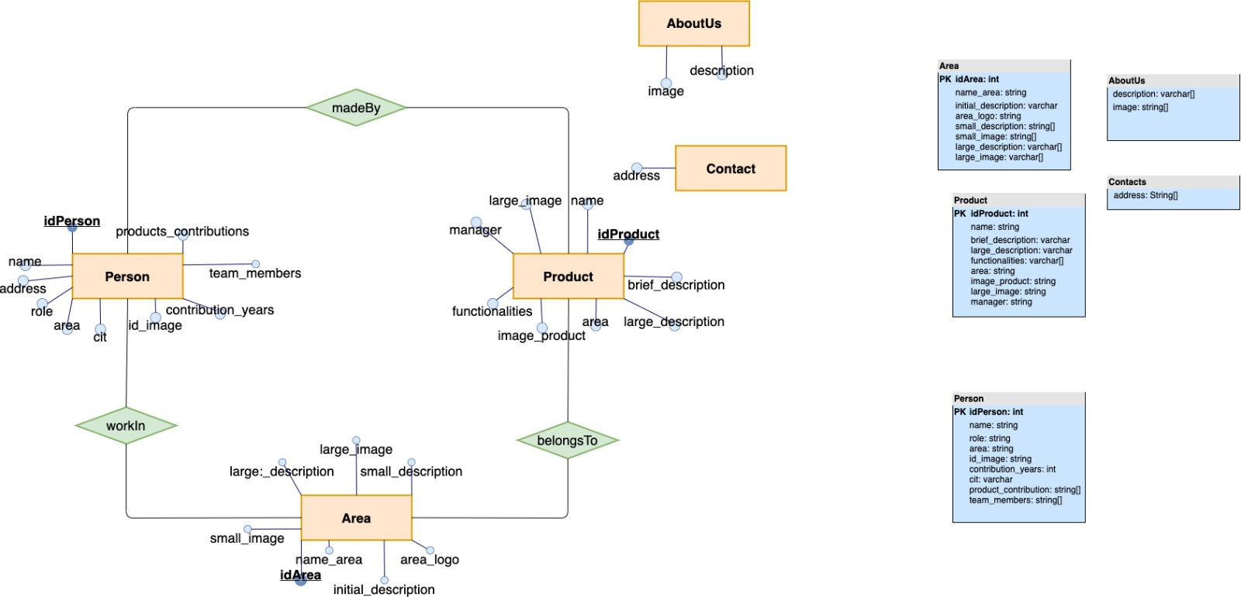

The Area, Person and Product databases are closely related:

* Each product is associated with a responsible person and an area to which it belongs
* Each person can be responsible for one area and for several products
* Each area has its own manager and several products

Contact and AboutUs databases don’t have a relationship.